Omer Kacar

M00719709

**Description**

My website includes a ‘Home’, ‘Game’, ‘Leaderboard’, ‘Login/Register’ and ‘Logout’ page as described in my project proposal. My website also includes a navigation bar for all of these links and a footer, and logo.

I have looked back at my project proposal numerous times in the process of building the website to ensure that I stick to the plan. This helped me greatly in executing my ideas and plans.

**Report:**

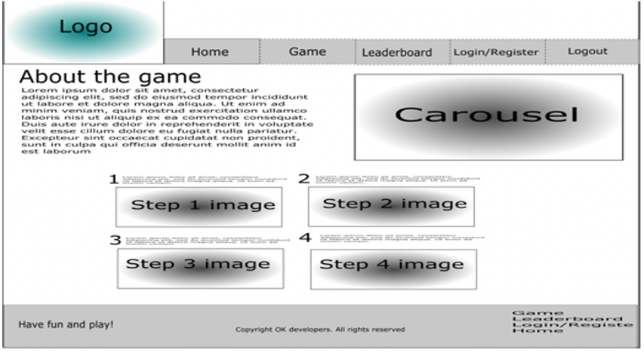

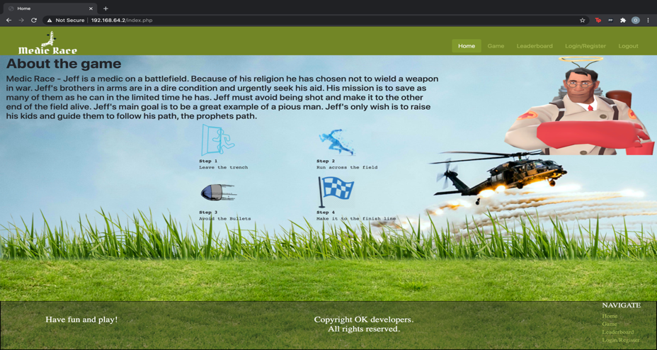**HOME PAGE**

The home page matches how I planned to design it. Including a table for the steps to play, followed by the carousel along with the introduction to the story of Medic Race.

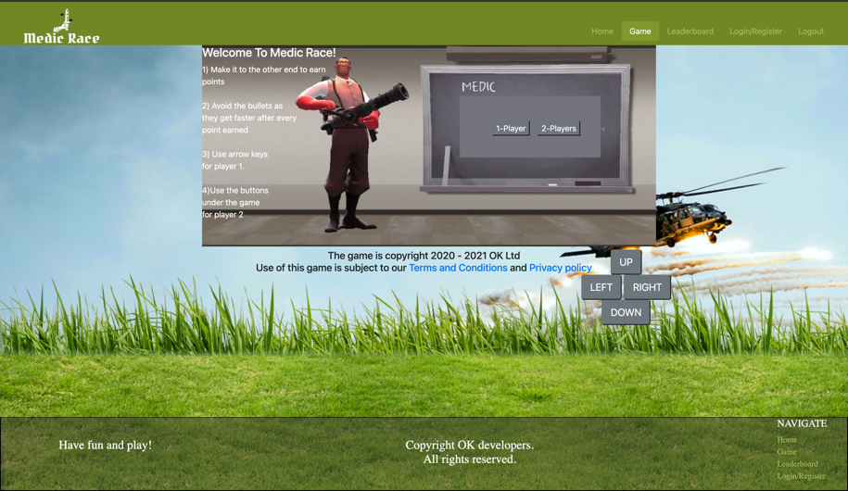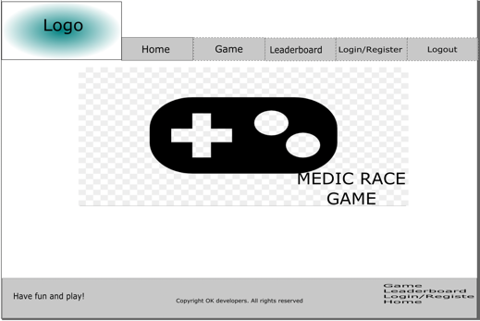**GAME PAGE**

As described in my project proposal, the game does include a start menu with information on how to play and an option to play two players. The game runs for 30 seconds. As the player attains more points, the bullet’s speed up which increases the difficulty of the game. The player cannot leave the canvas and once the player makes it to the top end of the field, the player gets a point.

The below images show how the game looks:



To not confuse the players, I changed the colour of player two’s sprite. When a player moves in a director the player’s sprite also looks in that direction. The image on the left is the game in two player mode and the image on the right is the game in one player mode. I made the bullets big so that they would be more visible and so that it would be more entertaining. I used many functions, and lines of code to build the game with the use of objects and classes. This whole game was built and designed by me with no modification. When the timer is over, if the user is logged in, the user’s score is updated if it is their highest score. The user can then choose to play again if they wish.

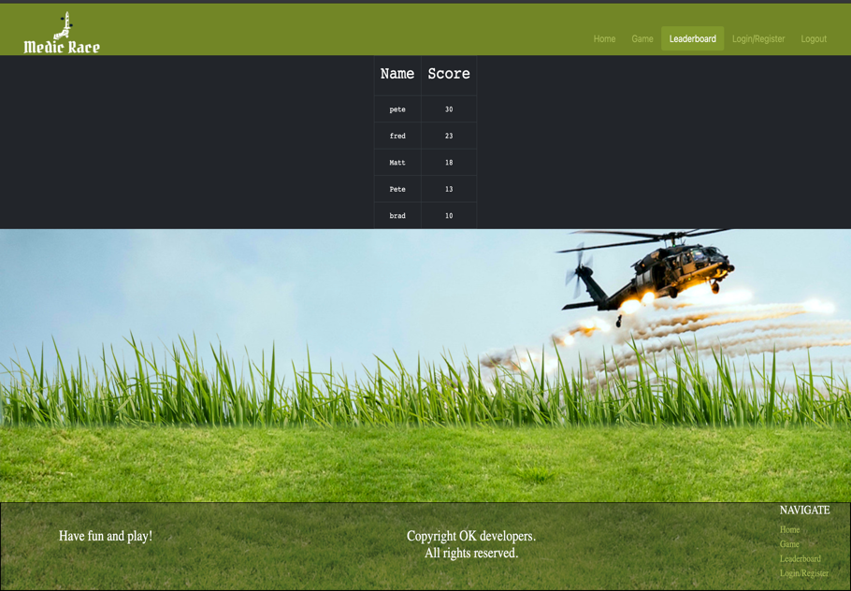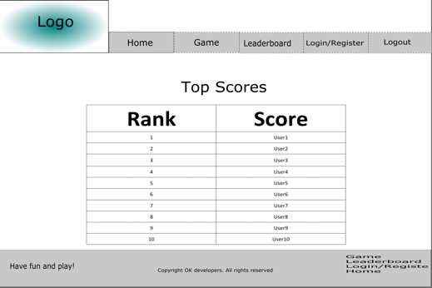**LEADERBOARD PAGE**

The ranking page includes the player name and score in the order of highest to lowest score. After creating objects of users in an array, I used a bubble sort algorithm to sort the users and their scores and place them in the table. When a new user registers, their name is added on to the list with a score of 0 until they play the game and get a better score.

**LOGIN/REGISTER PAGE**

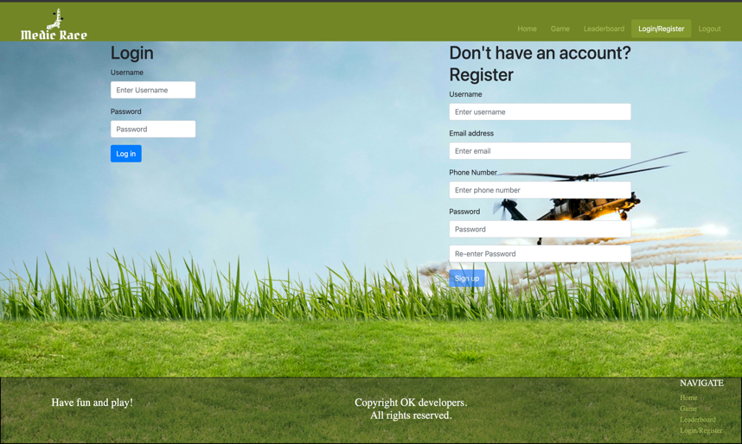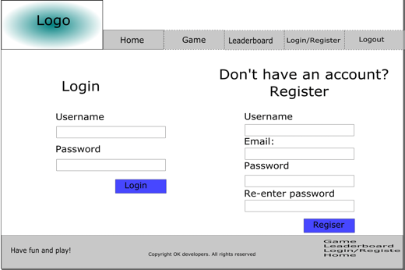

Furthermore, for the registration numerous error handling conditions and functions. For missing input fields. An error for an already used username. The email must have an ‘@’. The password must meet the stated requirements (otherwise the registration button will not become active). The phone number must have 11 digits and begin with “07”.

Other error handling functions and conditional statements were looking for ‘undefined’ users or a user named “undefined” in session storage was was an issue but I fixed it by looking for both ‘undefined’ and “undefined” user logged in.

For the login I made validations such as checking to see if such a username already exists. And checking to see if the username or password is correct.

Once the user is logged in, the log in button becomes disabled so that the user won’t be able to log in twice.

After logging in, the user can log out on any of the pages on the website by clicking the ‘Logout’ on the navigation bar.

**LOGOUT PAGE**

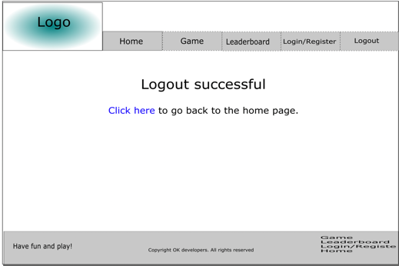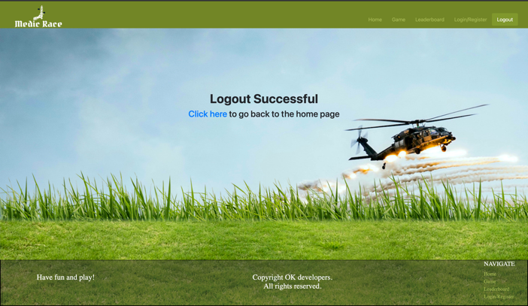

The logout page is exactly how I planned it, with the simple bit of text in the centre stating that the user has logged out and a link to the homepage.

On the php file I used an extra conditional statement for this. I did this because the ‘Logout’ navigation button would not show as an active button when clicked. Once the user clicks ‘Logout’, the session storage is cleared, and no user is logged in.

The logout, login/register, leader board and game were all typed in JavaScript and objects; furthering my knowledge into object oriented programming

For the registration, login and leader board I modified as much of the lecturer’s example codes as I could, and I added more functions and conditions to them too.